ScanPrint scanner firmware update

- Plug in the USB lead.
- Run HSC_PROG.exe
- The window should display Vendor ID, Product ID, Product Version and other information.

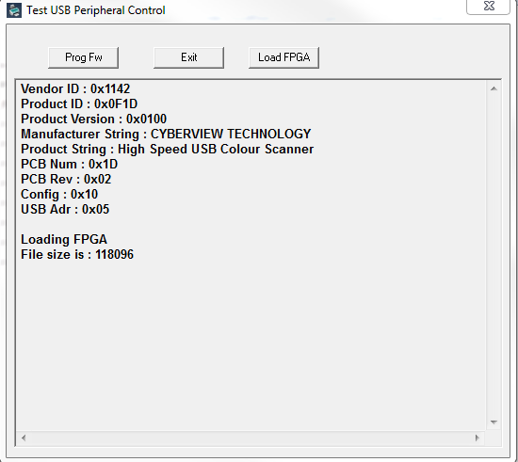

- Click the "Prog Fw" button

- The window should display "Erasing SPI Flash"
- The final message should be "FPGA Programming in SPI flash Done".

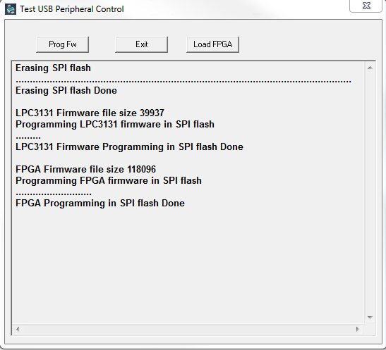

- Exit the program

